http://www.extension.umn.edu/distribution/naturalresources/components/DD6946f.html

Developing Shoreland Landscapes and Construction Activities

What Are Shoreland BMPs?
Best Management Practices (BMPs) are actions you can take to reduce your impact on the environment. BMPs have been described for agriculture, forest management, and construction. This fact sheet describes BMPs you can adopt on your shoreland property to help protect and preserve water quality. In many cases, the best management for shorelands may be retaining the natural characteristics of your property.

Why Is a Landscape Plan Necessary?
Whether you are landscaping your property, building a cabin, or designing a large resort, each land parcel has limitations for development. Limitations may include the type of soil, steep slopes, native vegetation, and other landscape features.
Plants and trees help to hold the soil and prevent erosion, especially on steep slopes. Removing them to establish a lawn increases the chance for soil erosion. Soil erosion can lead to structural damage, reduce soil fertility, and fill in road ditches. It harms your river or lake by causing excess sedimentation, killing aquatic bottom life, and disrupting spawning. The sediment, with accompanying nutrients, may lead to algal blooms, decreased lake depth, and reduced aesthetic appeal. All of these potential problems are expensive to correct and, more importantly, can be avoided by proper water and landuse practices.
Use existing features of your landscape in creating your plan. You can prevent problems by working "with the land" rather than against it.

Getting Started
The most important steps in getting started are to draw a detailed map of your property (see Figure 1 as an example) and to check with your planning and zoning office for local requirements. On the map, take care to accurately note these important features:
- hills and sloping areas
- location of roads and driveways
- potential building sites
- drainage patterns
- sewage treatment systems
- existing vegetation
- wildlife habitat
- land features such as wetlands and rock outcrops
- water wells
Next consider your long-term objectives for the property:
- How long do you plan on owning the property?
- What space do you require for your outdoor recreation activities?
- Do you want to create additional wildlife habitat?
- How compatible are your ideas with the expected long-term development objectives of the area?
- Do you plan on expanding or remodeling in the future?
- Does the "lay of the land" suit your ideas?
These and many more questions should be explored, including considering the potential uses for your property.

Developing Your Site Plan
The site plan should be based on your long-term objectives and the suitability of the land for these uses, with precautions taken to prevent soil erosion and water pollution. With these considerations in mind, your site plan will optimize the natural beauty and attributes of your property. The site plan can be a one year, ten year, or a twenty-five year plan, depending on your resources and time. But remember, the longer you wait, the more difficult and costly it will become to fix erosion problems.

Layout of Your Grounds
If you have the freedom to arrange your buildings and grounds, you can reduce water runoff problems in several ways. Locate driveways, walks, and yard and garden edges to follow level contours and gentle slopes. Do not lead water directly downhill. This gives it maximum speed and cutting power for erosion. Long, steep slopes have the greatest erosion potential. Consider putting small dams at intervals in ditches to slow runoff water and trap sediment. Cross-slope designs are better than up-and-down-hill ones.
The site plan you develop is critical. Site your septic system and water well in suitable areas before you finalize building locations and landscaping plans.

General Guidelines for Landscaping
- Keep the site covered. Any disturbance of ground cover (grass or shrubs) will expose soil. This leads to erosion and slope failure. Use hay or straw as a mulch to cover disturbed areas after reseeding. A good rule of thumb is one 50-pound bale per 500 square feet. Consider working only in a small area and stabilizing that site before disturbing another.
- Minimize disturbance to plants and trees. Select and save trees to gain time in landscaping later. Protect trees from heavy equipment by encasing them with heavy planks tied vertically around the trunks. Large trees, especially birch, can be killed by heavy traffic that compacts the soil. Putting fill material too deeply over the root area can also kill trees.
- Maintain a filter strip of natural vegetation along the banks of lakes and streams. The best filter strip is mature woodland with undisturbed grass and shrub layers.
- Establish permanent cover. After your grounds have been graded to minimize and control runoff, the next step is to plant a permanent cover on all areas that have been disturbed. Trees and shrubs are excellent at protecting soil from rain and are practical erosion-control measures. Use native types of trees and shrubs wherever possible. They are well adapted to our climate, insects, and diseases. Native trees and shrubs also create a landscape that needs minimal maintenance and is more natural.
- Plant trees and shrubs to help buffer harsh winter winds and provide shade during hot summer days. Plants also serve as a living "fence" to provide privacy and excellent habitat for birds and other wildlife.
- Use pesticides and fertilizers carefully. Use only approved pesticides and follow label directions. See fact sheet #9 for more information.
- Plan streets and roads. Roads that follow general contours and moderate slopes offer less obstruction to natural drainage. They are also easier to stabilize and maintain. Plan driveway grades of 10% or less. Where steep slopes cannot be avoided, consider putting in "water bars." These small, raised ridges on the road surface help to route runoff water to road ditches, rather than allowing it to run the entire length of the slope. Properly sized culverts are also important for a well-drained road bed. See fact sheet #8 for more information.
- Control runoff. Rainfall and snow melt runoff should be directed to safe drainageways so that water will not scour and wash away soil. Curbs of dirt, timber, or other materials can be placed at the crests of steep hills or cuts to divert runoff away from unprotected slopes. Diversions can also be constructed to control runoff. They collect runoff and lead it downhill to a safe outlet.
Don't forget that "hard" surfaces are impermeable to water and increase runoff. These impermeable surfaces include building roofs, roads, driveways, and patios. Minimize the amount of hard surfaces to help control excess runoff.
To prevent runoff damage by water:
- keep it spread out, moving slowly
- divert it away from sensitive areas
- direct it to flow over erosion-resistant materials such as dense sod, rocks, plastic sheeting, or concrete
- protect natural drainageways from filling with sediment
Check these off as you draw them on the plan:
_____contour elevations of your property (OR note steep slopes and flat areas)
_____areas where you will be excavating and filling soil types (e.g., clay, sandy loam)
_____property boundaries
_____setback distances between shoreline and structures
_____elevations of important features such as buildings, drainage outlets, or wetlands
_____drainage patterns (streams or drainageways)
_____location of electric, gas, water, or sewer utilities
_____areas needing protection to prevent erosion such as unstable slopes and steep embankments
_____vegetation (to be removed, added, or left as is)
_____ordinary high water level of lake or river
_____scale (usually number of feet per inch)
_____north directional arrow
Big, old dead trees, brushpiles, and unmowed grass are "home" for a wide variety of wildlife. Save these whenever possible.
Use vegetation to help direct people away from sensitive areas, such as steep slopes.
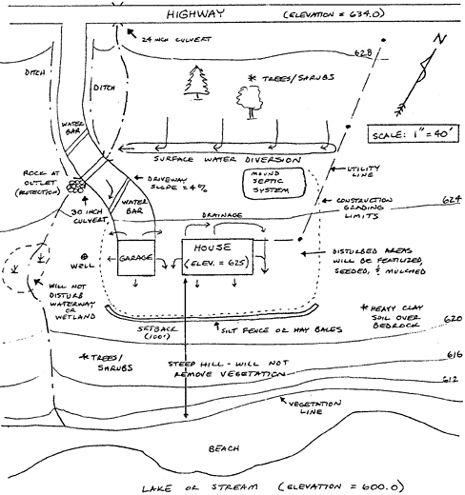
Figure 1: A landscaping plan should include roads, buildings, topography and slope, shoreline, and vegetation.
Remember to maintain an adequate turnaround area near your home for emergency vehicle access.

